Predicting Carbon Dioxide Concentrations Using Machine Learning
MMA3001 – Numerical Methods and Machine Learning
Student – Amelie Elliott | ID: 36135671
Dataset: Monash Smart Infrastructure Occupancy and Environmental Data (Dataset 2)

- Engineering Problem
Indoor carbon dioxide concentration is measured regularly within occupied buildings to provide crucial information about the environmental conditions of the buildings as well as safety of individuals using this infrastructure. Carbon dioxide concentrations can change for many reasons, including occupancy, ventilation and other environmental conditions of the building. Engineers operating on this infrastructure may find these forecasts beneficial as they would indicate when carbon dioxide readings are likely to increase in the future, enabling engineers to be more informed and investigate accordingly. This project evaluates if only historical sensor measurements can provide useful forecasts of carbon dioxide an hour ahead.
Research question: Can linear regression or decision-tree regression predict the carbon dioxide concentration within an hour in the future with greater accuracy that a simple baseline prediction and assumes the current reading will be the same as the one before.
At each of the prediction points, five of the carbon dioxide observations in the previous hour are utilised to estimate the reading an hour later. The forecasts are measured in parts per million (ppm). The Engineering product is an evidence backed comparison of the accuracy in forecast prediction, runtime and complexity of the models.
Scope and intended use:
The project uses the supplied environmental sensor data from dataset 2, and selects one sensor which has the greatest number of readings to base comparisons on. It doesn’t include the occupancy data and other environmental variables on purpose, to ensure it addresses the overall general problem. As a result, any risks from invalid sensor to room connections are discarded and enables the project to be a focused comparison of the topics taught throughout the unit. The output from this project could provide useful information for building monitoring in the future, with engineers using this information to guide future research. However, the findings should never be considered as a health and safety risk assessment or as evidence that certain conditions change carbon dioxide levels.
The main comparison measurement is the mean absolute error (MAE) on a chronically divided validation set, with a lower MAE indicating greater accuracy of a method. The root mean square error (RMSE) is reported in order to demonstrate sensitivity to large errors. A final dataset that wasn’t used during training or the selection of the model was used to test how accurately the chosen model predicts carbon dioxide measurements on new data.

- Inputs and Outputs
The input is the given Monash environment sensor data in the form of a ZIP file which has a CSV table. Each row in the dataset has a sensor ID and measurement stored in JSON format. The program uses data entries with the variable label under “Carbon dioxide”, as well as timestamps and the measured concentrations. Timestamps are converted into universal date and time format and the carbon dioxide measurements are converted into values measured in ppm.
Item | Format, interpretation and units
Top-level input | ZIP file with a CSV containing sensor data and JSON measurements
Sensor selection | Sensor with the most carbon dioxide readings
Sampling resolution | Sensor readings are divided into 15-minute intervals, with the median value calculated for each interval
Predictors | Carbon dioxide at t, t-15, t-30, t-45 and t-60 minutes (ppm)
Outputs | Predicted carbon dioxide concentrations, a CSV file with model accuracy results, a JSON file of results summary and a graph with the predictions.
Performance outputs | MAE (ppm), RMSE (ppm), time (seconds), total pipeline time (seconds).

Data preparation and data exclusions:
The project excludes data entries with invalid timestamps or concentrations that are not a number, and includes readings between 250 and 10,000ppm. These limits are used as a check to ensure sensor readings that seem unrealistic or incorrect are removed. If there are multiple readings with the same timestamp, the median is used. Measurements are then grouped into 15 minute intervals, with the median value being used. Furthermore, if a 15 minute interval has no sensor readings, it is left empty instead of using estimated values.
The program utilises previous and current carbon dioxide measurements that are taken at 15 minute intervals to construct a table of inputs which are used to predict the future carbon dioxide level. Then each set of inputs is matched with the actual carbon dioxide level which is recorded 60 minutes later, enabling the model to learn from the data. This approach doesn’t use estimate values which means it can only be tested on time period where all the required carbon dioxide measurements are available.
Software interface and how failure is dealt with:
The python code requires an individual to say where the ZIP dataset is. Furthermore, there are options that allow the induvial to choose where to save the results, choose a certain sensor and give a limit for the number of data rows read. The program checks for invalid prediction settings, ensuring there is sufficient data measurements available for the model analysis. From this, if there are incorrect values given or fewer than 100 measurements, the code will give an error as a result. Moreover, the dataset provided contains measurements from May to December 2024, however data readings may be recorded at inconsistent intervals, so the 15 minute time intervals is introduced to address this.

- Computational Solution
The program uses five carbon dioxide measurements, including the current and previous readings within an hour earlier, to predict the carbon dioxide concentration an hour later. As such all measurements utilised for the future prediction are already available at the current time period. The program uses Pythons pandas library to ensure all previous measurements are organised in the correct order, and ensure the removal of any rows with missing values.
  - Persistence benchmark
The persistence benchmark is a baseline that predicts the concentration will remain the same within the next hour. It doesn’t need any training and offers a measurable baseline for the model to be evaluated against.
3.2. Linear regression
Linear regression is used to predict the future concentration through finding a relationship between the previous five measurements and the current carbon dioxide measurements and the level an hour later. The model works by calculating coefficients for each measurement, in order to reduce the differences between the predicted and actual carbon dioxide levels. An advantage about this method is that it is fast and easy to interpret, however it can be less accurate when carbon dioxide levels change in more complex ways.
  - Decision tree regression
Decision tree regression predict the future carbon dioxide levels by dividing the training data into smaller groups and basing this on the previous carbon dioxide measurements. Each group is utilised to find an average carbon dioxide value, and this becomes the prediction. Decision tree can be used to find more complex patterns in the data, and as such is not like linear regression in this way. However, trees that are too complex may overfit the training data, and result in models which perform well on existing data but not on new data. To compare performance three tree depths are testing, including 3, 5 and 8. Each group must have at least 20 training examples, and a fixed random state of 42 is utilised to make sure the results are consistent when the program is repeated.
3.4 Implementation and selection of a model
The program uses python, panda and NumPy for data preparation, and matplotlib to create any graphs needed. The data is kept in order and separated into 60% for training, 20% for validation and 20% for testing. There are eight examples which are removed in preparation for validation and testing so that no overlap occurs between the datasets. The five predictions methods are compared with their mean absolute error (MAE) being used on the validation data. The model with the lowest MAE is chosen to be the model which performs best, and this is then evaluated using the testing data. By removing eight examples this reduces any overlap between the datasets, but cannot guarantee they will remain separate as carbon dioxide measurements taken close together may still be related.

- Alternative solutions
The project compare five approaches including persistence, linear regression and decision trees with maximum depths of 3, 5 and 8. All methods utilise the same previous five carbon dioxide inputs and the same validation period, ensuring a consistent comparison of predictive error and cost of model fitting is made.
Model | Validation MAE (ppm) | Validation RMSE (ppm) | Fit time (s)
Tree depth 3 | 11.30 | 21.08 | 0.01180
Tree depth 5 | 10.84 | 20.53 | 0.01211
Tree depth 8 | 10.90 | 20.55 | 0.01917
Linear regression | 11.81 | 22.23 | 0.00553
Persistence | 12.79 | 29.65 | 0.00000

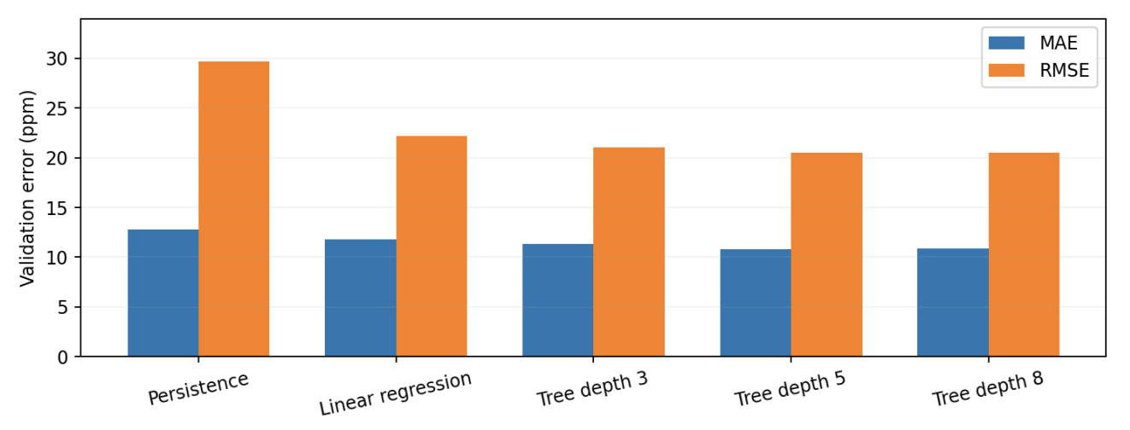
Figure 1. Validation MAE and RMSE for all five methods. Lower values indicate greater accuracy.
Tree depth of 5 gives the lowest validation MAE (10.84ppm), compared to 12.79ppm for persistence and 11.81ppm for linear regression. It also has the lowest validation RMSE (20.53ppm). This provides justification for selecting the tree depth of 5 for the final approach. However, the differences between depths of 5 and 8 are small. The baselines has no fitting cost essentially. Linear regression fits in around 0.00553 seconds, the tree depth of 5 takes around 0.01211 seconds. Kallio et al. (2021) depicts that decision tree models can accurately predict indoor carbon dioxide concentrations while remaining technologically efficient, as such the use of a decision tree regression in this project is supported by this.

- Validation

  - Why chronological validation is appropriate
Randomly dividing the data into training and testing groups can allow for older and newer carbon dioxide measurements to mix, which can give results that are misleading regarding the accuracy of the model in predicting future measurements. To avoid this, the project keeps the measurements in chronological order, so they are organised according to earliest and latest. The first 60% of the data is used to train the models, and the next 20% is used to compare models and their accuracy to select the best one, and the final 20% is used to test the selected model on data it hasn’t been tested on before.

Quantity | Recorded value
Extracted carbon dioxide readings across sensors | 179,447
Selected sensor ID | 6012002000326
Missing 15 minute bins in selected series | 62,790
Training examples | 9,988
Validation examples | 3,324
Held-out test examples | 3,332
Selected model | Decision tree with a max depth of 5 and minimum lead samples of 20

  - Error metrics
The mean absolute error (MAE) is the difference between the actual and predicted concentration. The root mean square error (RMSE) is the square root of the MAE and usually penalises larger errors more. Both have units of ppm.

5.3 Final held-out performance
Final metric | Decision tree with depth of 5
Test MAE | 11.2369ppm
Test RMSE | 25.8319ppm
Held-out examples evaluated | 3,332

The test MAE is close to the validation MAE of 10.84, whereas the test RMSE increases from 20.53 to 25.83ppm. This indicates that there are some large forecast error within the test period. Moreover, the original pipeline doesn’t report that the persistence model’s held-out test error, as such the validated 15.3% MAE improvement over persistence shouldn’t be presented as a measured test set improvement.

5.4 Evaluating the forecast behaviour
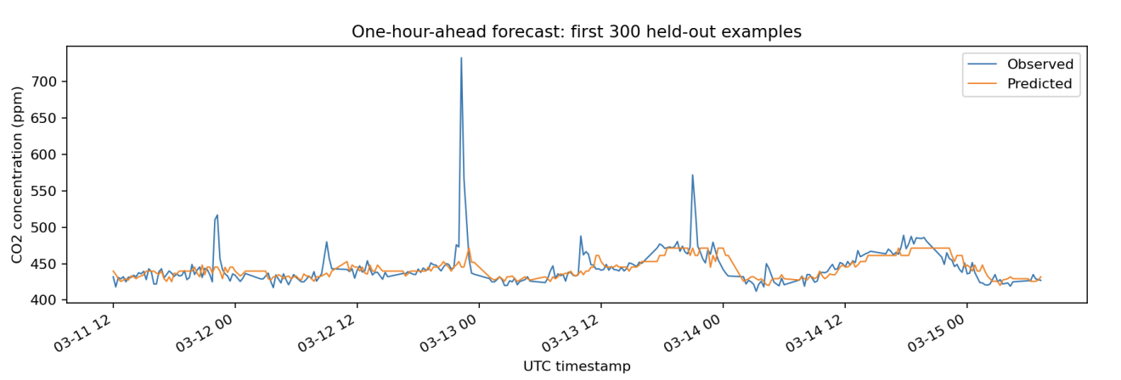
Figure 2. observed and predicted carbon dioxide for the first 300 held-out test examples.
The graph depicts that the model generally follows changes in the carbon dioxide concentration, especially when the levels remain relatively stable. However, the model finds it challenging to predict sudden increases, as such it often produces lower values than those realistically recorded. These larger differences explains the RMSE results as the RMSE places greater importance on large prediction errors. The only uses previous carbon dioxide measurements, and as such it can be difficult to predict sudden changes that weren’t indicated by the previous readings.
5.5 Software verification
Six tests were completed and passed to check that the python program worked without errors. These tests checked that the program predicts carbon dioxide at the correct future time, efficiently deals with missing measurements, separates the data in chronological order, calculates prediction errors and will select a sensor when one isn’t given. These tests show that main parts of the program work effectively, but cannot make sure that for certain the sensor measurements are accurate or that the model will perform well in other environments.
5.6 Limitations of the validation
The model was testing only using data from one sensor, with incomplete measurements removed. As such the results aren’t guaranteed to reflect periods of missing data or predict the carbon dioxide levels effectively in other buildings. Moreover, ventilation rates weren’t measured, so any results can’t determine how effectively the buildings ventilation system works.

- Optimisation and performance
The optimisation process involved testing the tree depths of 3, 5 and 8, and keeping the minimum number of training examples per final group of 20. Smaller depths may miss important patterns, however larger depths are at risk of overfitting the data. The models were compared based on their validation MAE to determine which model performed best and was then selected.
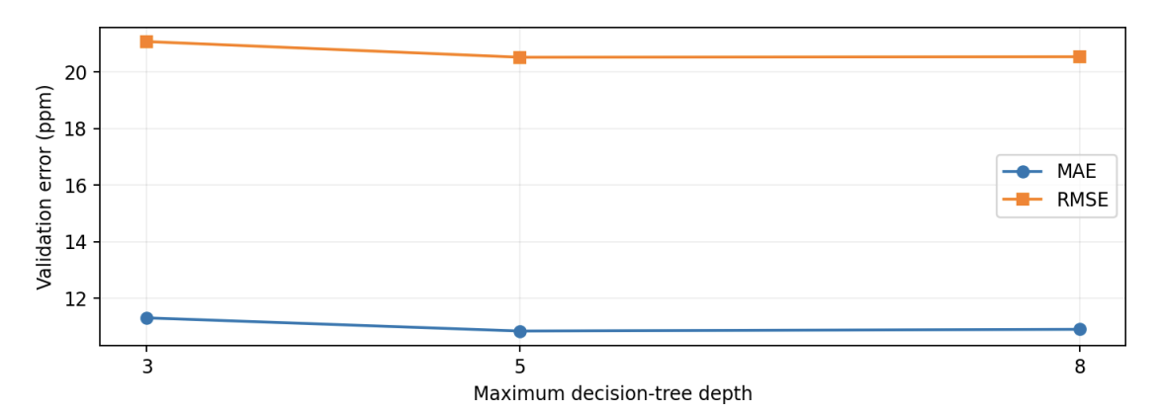
Figure 3. Comparison of validation MAE and RMSE for decision tree depths 3, 5 and 8.
Increasing the depth from 3 to 5 reduces the MAE from 11.30 to 10.84ppm. However, increasing it to 8 slightly increased the MAE to 10.90ppm. As such the depth of 5 was selected as it had the lowest error.
  - Computational cost and trade offs
The program took around 5.92 seconds to complete fully, with the individual model training times ranging from 0.0055 to 0.0192 seconds. While the depth of 5 took slightly longer than linear regression, it is the preferred model as its accuracy is greater. These program times can vary depending on the computer and the size of the dataset.
6.2 Engineering limitations
The model predicts future carbon dioxide levels using the patterns in previous measurements, instead of using any equations. The accuracy of the model is influenced by the quality of the sensor data as well as any missing readings, changing building conditions and seasonal differences. In conclusion, the project demonstrates the importance of preparing data correctly and effectively, as well as comparing different models and using different datasets to evaluate the prediction accuracy.

- AI use and reflection
ChatGPT (OpenAI) was used throughout the development of my project. Its contributions included helping understand regression methods, explain the project brief, suggest different topics for the project, generate code, the README, test and the figures. ChatGPT suggested that I used the environmental sensor data and helped develop the forecasting pipeline, including data cleaning, model training and testing. AI was very useful as it helped with my workflow throughout the project, helping when I got stuck or didn’t understand elements of the project or code. It helped explain unfamiliar concepts such as decision tree regression, persistence benchmarks, training and validation datasets and well as remind me how to use VS code. AI generated most of the initial code and helped my in knowing what concepts I needed to cover in the report, all of which was reviewed and adjusted to improve my understanding.
I also remained responsible for confirming that all AI generated work was verified and checked before submitting this project. I ran all code in VS prior to creating my repository and ensured it ran with no errors. Although ChatGPT did contribute largely to my project, any work from AI was not automatically put into my project without overview and verification from me. Any inconsistencies identified by AI was verified by me and corrected by me.

I faced many challenges throughout the project such as locating the dataset needed and the project files, running python code and understanding complex topics which I had little to no previous knowledge on. The report was an invaluable way of ensuring I understood all elements of the project, with little help from AI, except explain some results from the project and any foreign concepts, it allowed me to ensure I developed a deeper understanding of all engineering concepts discussed.
My main decision involved selecting the Carbon dioxide forecasting topic, reviewing any proposed methods, checking the project against the assessment requirements, running and validating all code in VS code and completing the report in full only using AI to ask questions and not generate any paragraphs.
Due to the complexity of this project, I was unable to complete it without assistance from AI, but it fostered my learning of concepts within this project, enabling me to learn so much and understand so much more than by myself. I used AI to bridge my own knowledge into the projects deliverables, enabling me to complete this project in full.
Through this project I was able to develop my understanding of how numerical and machine learning methods can be applied to data in the real world. I also learnt how to organise a python project, use GitHub, compare forecasting models using error measurements, better understand concepts taught in class throughout the semester, and how to improve code when any errors ran while I was verifying the code. Although coding is still very much a challenge for me, using AI helped me understanding the overall process and understand the importance of testing and verifying results, as well as ensuring that you are working with AI not just getting it to do things for you so you are still learning in the process.

References:
Monash University (2026). MMA3001: Numerical Method and Machine Learning – Project Brief.
Monash University (2026). MMA3001: Project Datasets – Environmental and Occupancy Sensor Data. Unit-supplied data description and environment archive.
Monash University (2026). Week 5.1 Linear Regression; Week 5.2 Decision Tree Regression. Lecture notebooks
Source of numerical results: results.json and validation_metrics.csv.
Kallio, J., Tervonen, J., Räsänen, P., Mäkynen, R., Koivusaari, J., & Peltola, J. (2021). Forecasting office indoor CO2 concentration using machine learning with a one-year dataset. Building and Environment, 187, Article 107409. https://doi.org/10.1016/j.buildenv.2020.107409

